CS 255 System Design Document Template

This template lays out all the different sections that you need to complete for Project Two. Each section has guidance to prompt your thinking. You will need to continually reference the interview transcript as you work to make sure that you are addressing your client’s needs. There is no required length for the final document. Instead the goal is to complete each section based on what your client’s needs are. Remove this note when you are finished, and replace all bracketed text with the relevant information.

UML Diagrams

UML Use Case Diagram
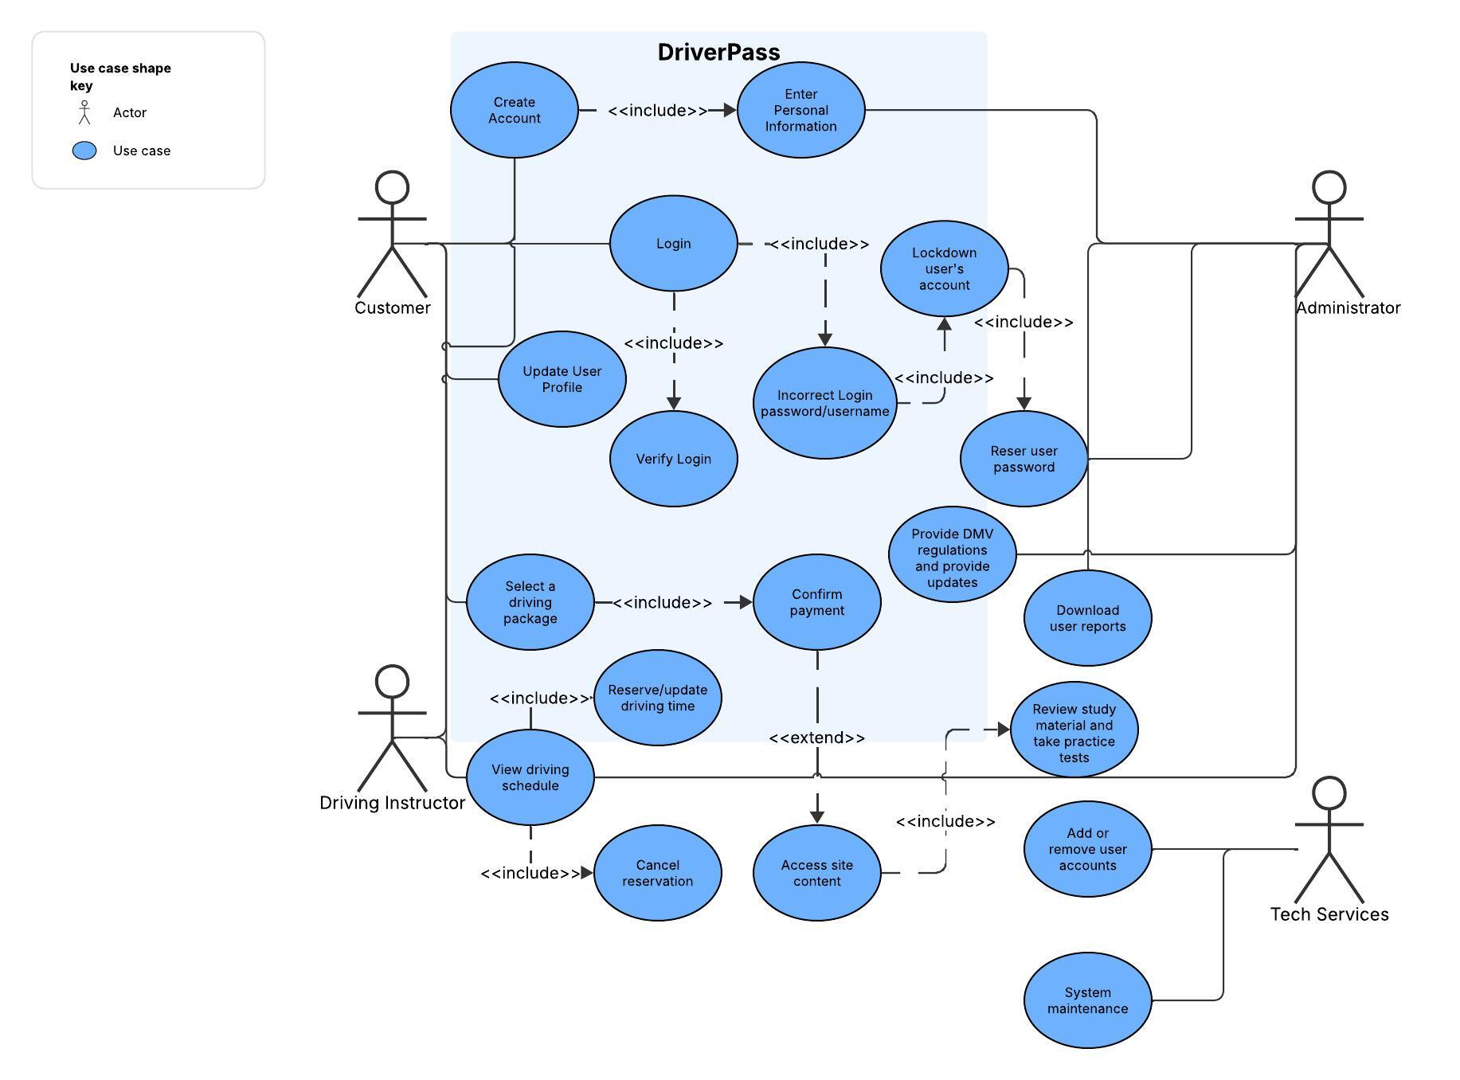

UML Activity Diagrams
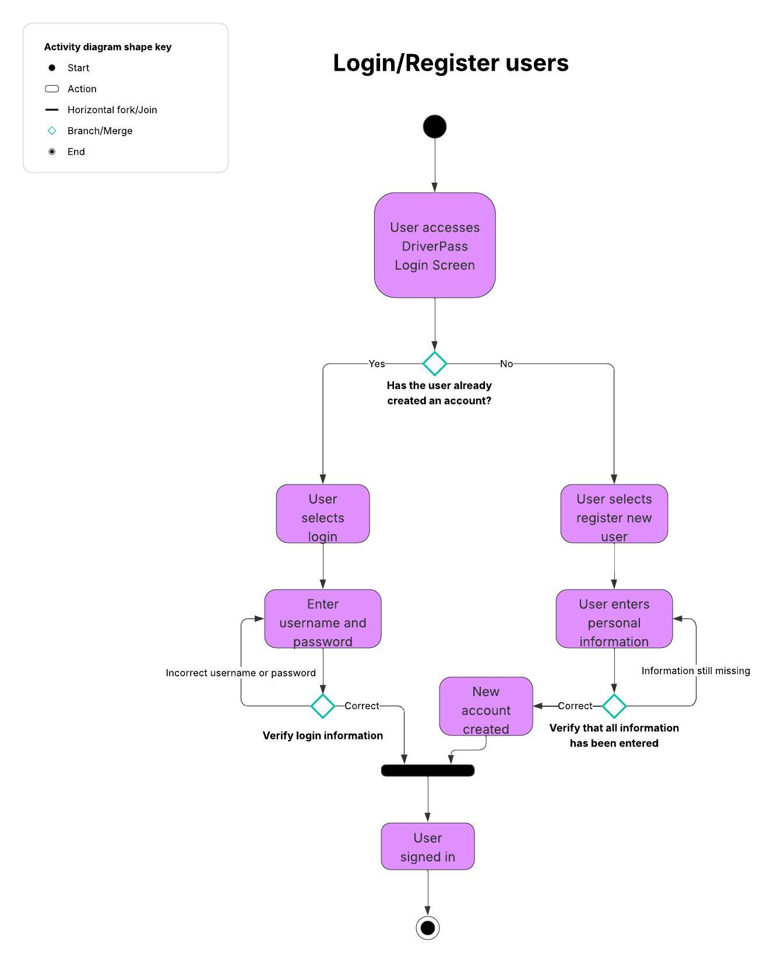
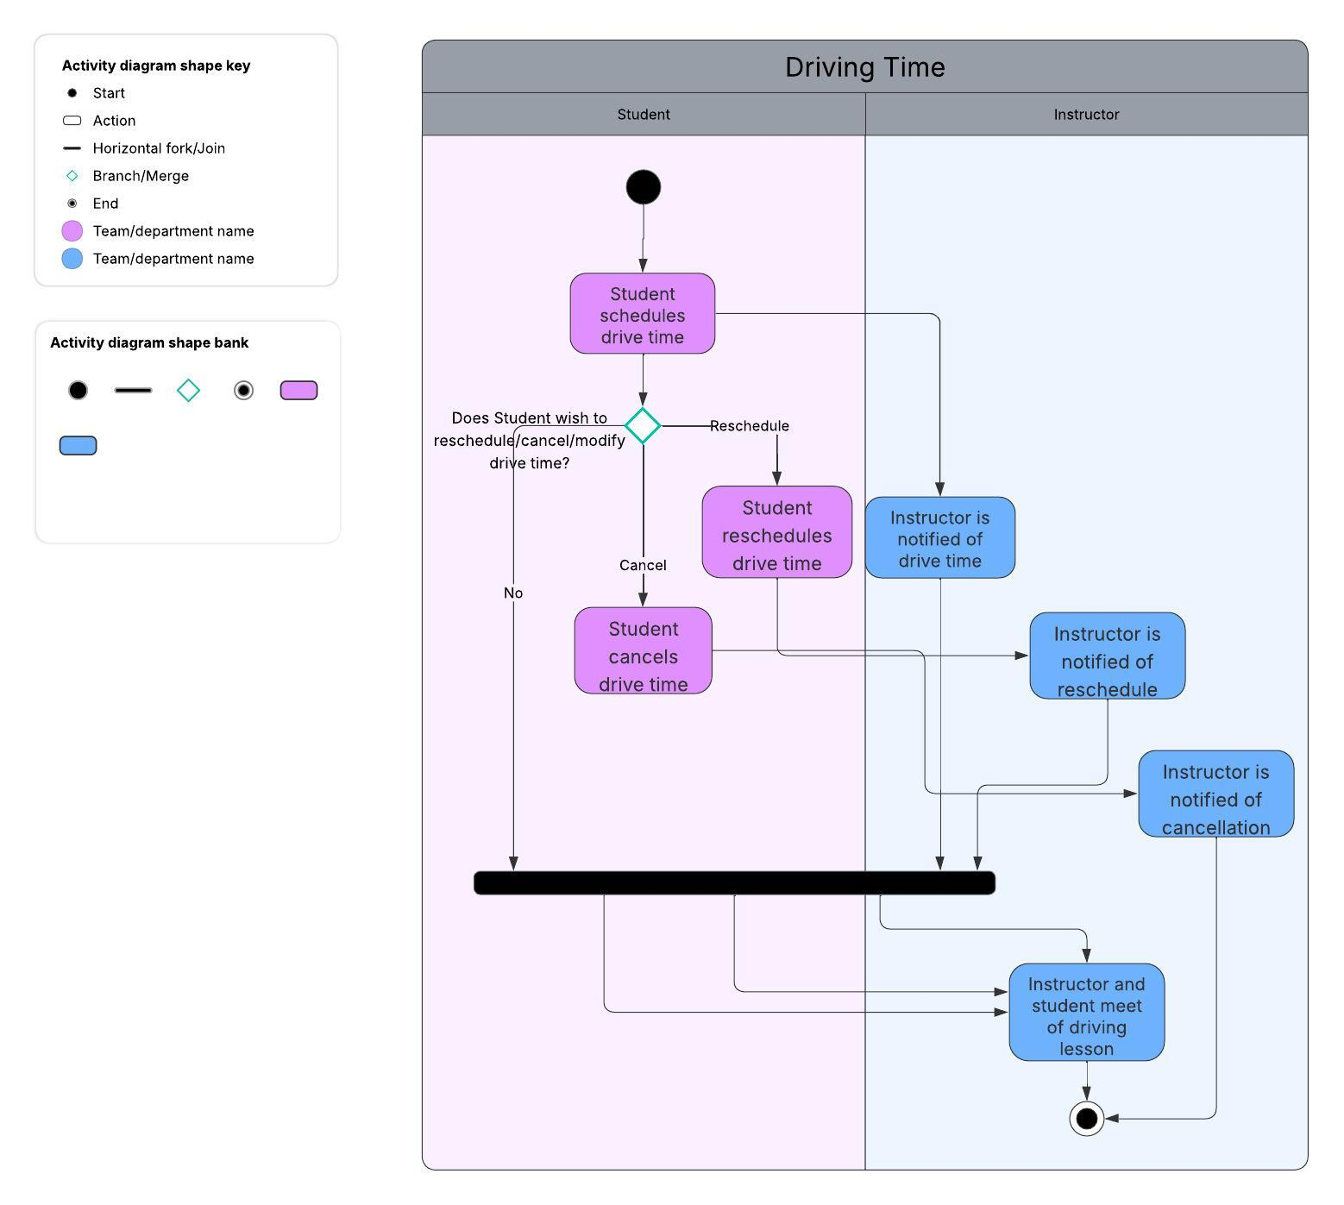

UML Sequence Diagram
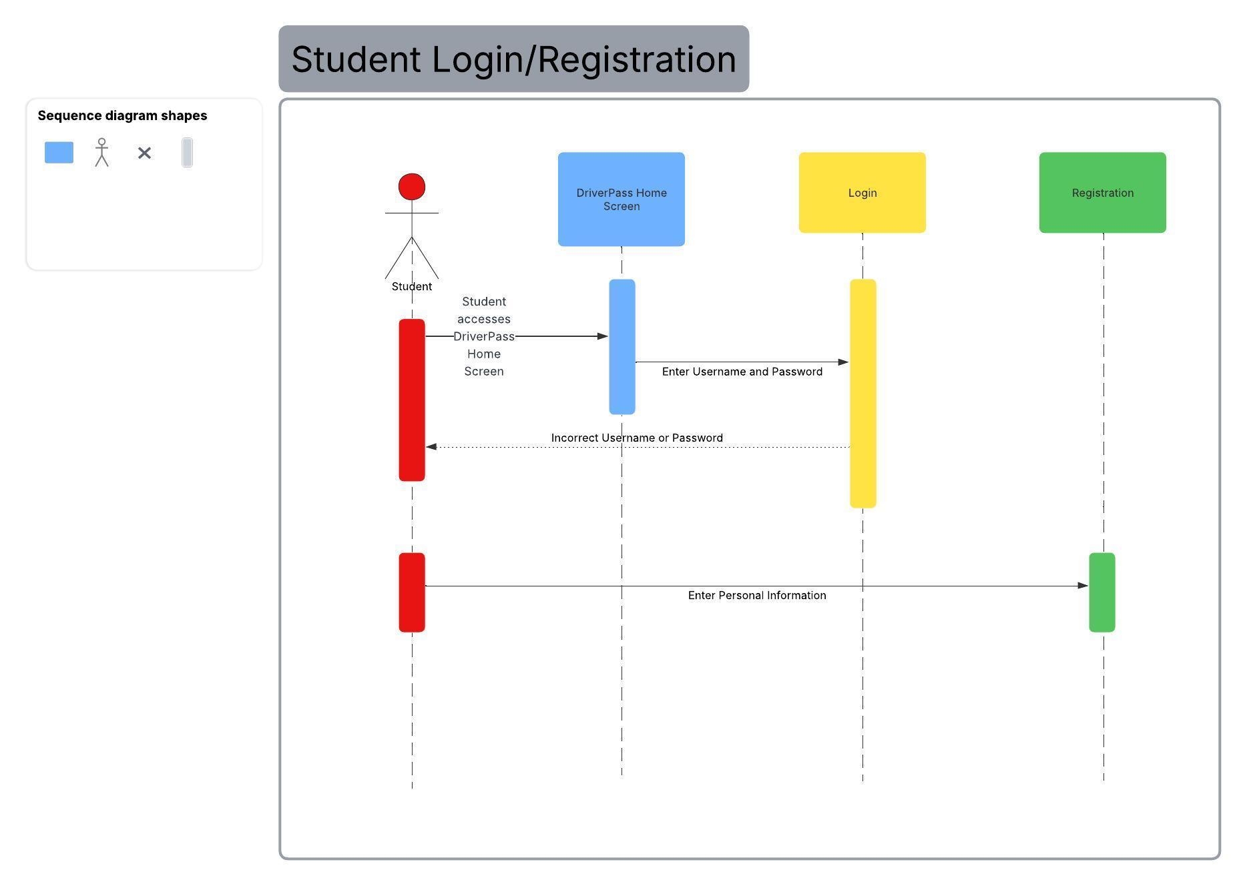

UML Class Diagram
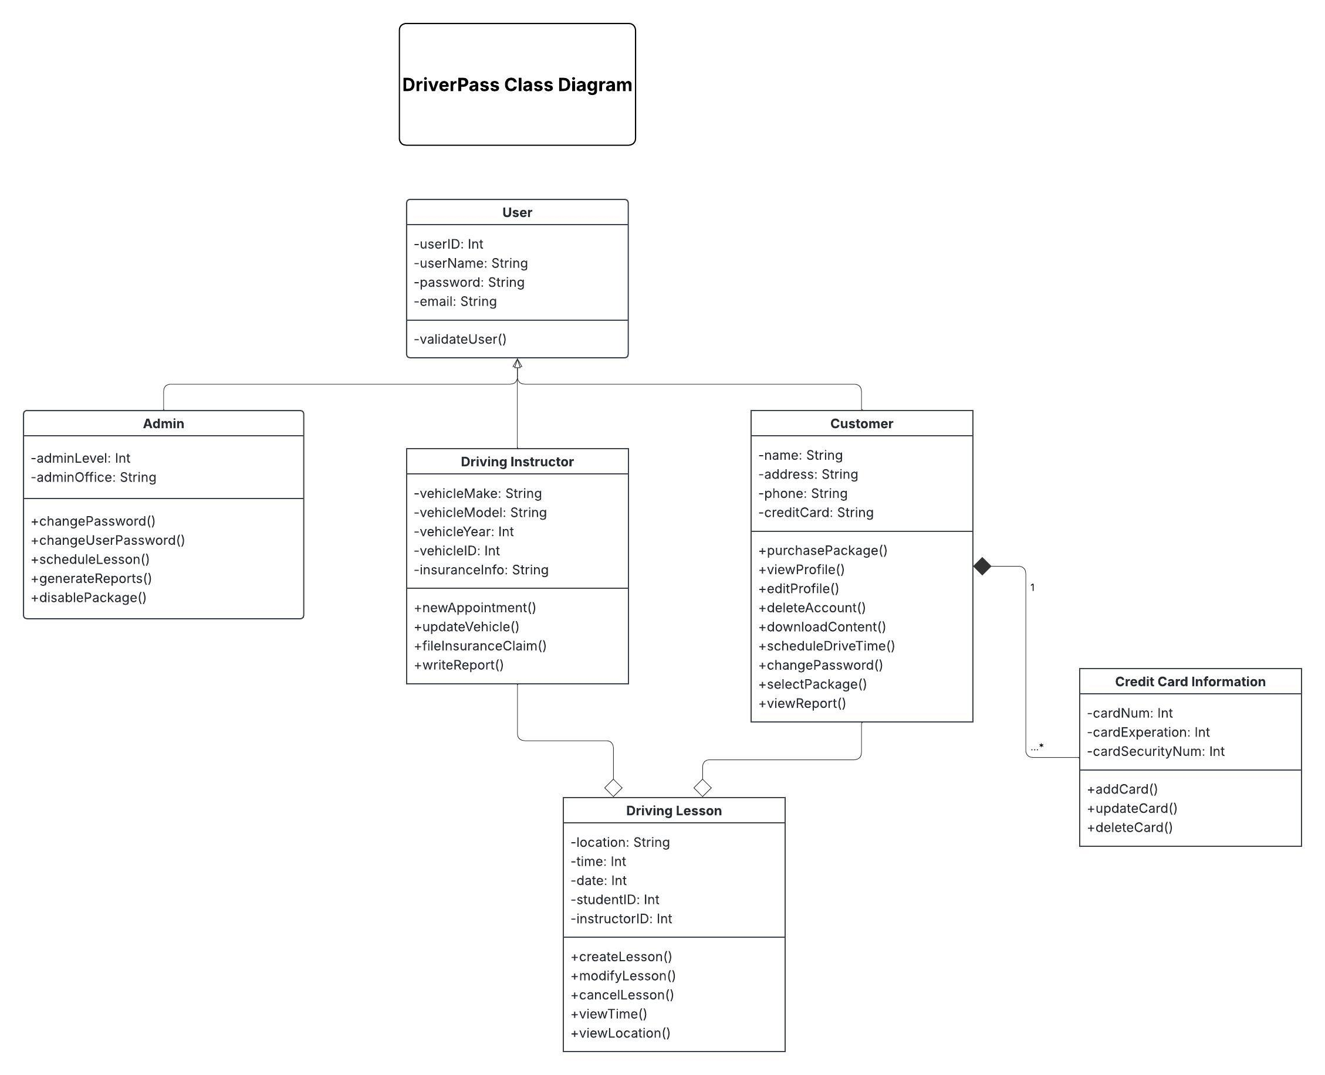

Technical Requirements
Hardware Requirements:
For DriverPass, they should have at least one physical server to handle backups for the system. They will also need basic equipment for maintaining their server such as cables for connections, fans for cooling, and a power source strong enough to support the system. DriverPass will need a computer to access the system and an internet provider to access the online functionality. For the customer, they will need a device (computer, laptop, mobile phone) that can access the system. They will also need access to the internet as this system is online.

Software Requirements:
For DriverPass, they will need a Windows operating system to run this program. They will also require the DriverPass system that we are creating if this system is to operate. Some form of software security to prevent attackers from accessing customer and instructor information. For the customer, they will need a web browser and an operating system capable of running this program. The customer should also have some form of security to prevent unauthorized access to their information.

Tool Requirements:
The developers will need programming software to write the code for the system. A stable internet connection for uploading to the server. There should also be a network administrator that can monitor the system to prevent attacks.

Infrastructure Requirements:
Either a physical server or a cloud server is needed (could have both). If physical servers are used, there must be a building big enough to house the server and there must be enough power to the building to run the server. A stable internet connection to prevent crashes and keep upload speeds fast. Enough vehicles must be available for the instructors to conduct lessons, and each vehicle must be insured by the state that they are operating in. A credit card processing third party will be needed for payments.

